Help us shape our future, and we’ll help you shape yours

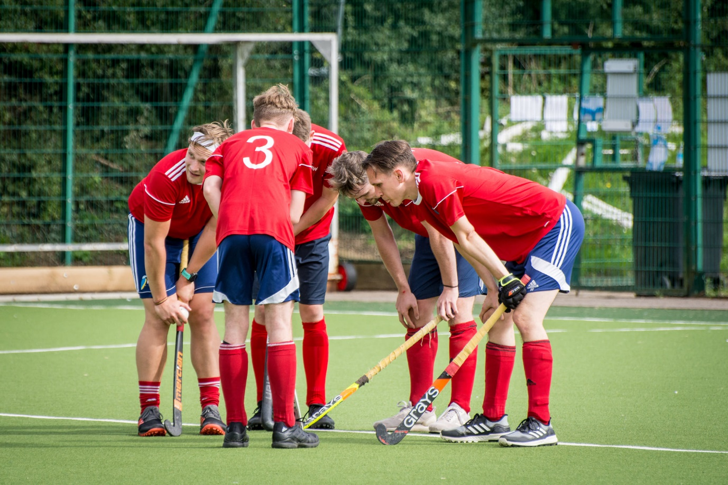

Why sponsor Redditch Hockey Club?
- Targeted advertising opportunities to our dedicated sport-loving membership, living in and around Redditch (current membership includes over 120 members with three training sessions per week and matches on weekends)
- Regular hockey fixtures played on our pitch throughout the winter season (September – April), with visiting teams from around Worcestershire and the West Midlands
- The pitch is regularly booked by other sports teams throughout the week, all year round
- The wider club is also home to Revolution Touch Rugby (whose ranks include England players) as well as the West Midlands Foxes Academy football team linked with Leicester City Football Club
- The opportunity to build relationships with our players through our events with an option for bespoke events to align with your business
- A committed communications team that share regular updates with our followers on Facebook and Instagram
- We value your investment and you’ll be directly contributing towards our vibrant hockey community, helping us to nurture future hockey talent

Let’s talk more about how we can work together

Our sponsorship and fundraising co-ordinator Holly Hancocks can be contacted at sponsorship@redditchhc.co.uk. You can also find us on Facebook, Instagram or on our website.

Sponsorship Packages
If you take up the opportunity to become closely associated with our club, we’ll create a sponsorship package that helps achieve your aims. Our current packages are below:

Gold Package (£1,000)
- 2 year agreement
- Company logo on the playing shirts of one of our league teams or Badgers team
- 1 single side advertising mesh banner (3m x 1m) on AstroTurf fencing
- 10% discount on membership to Redditch Hockey Club for any employees
- 2 membership cards entitling named persons to discounted drinks in the Clubhouse bar
- Written piece in Redditch newspaper and on club website about the sponsorship
- Presence on the Redditch Hockey Club website with reciprocal links

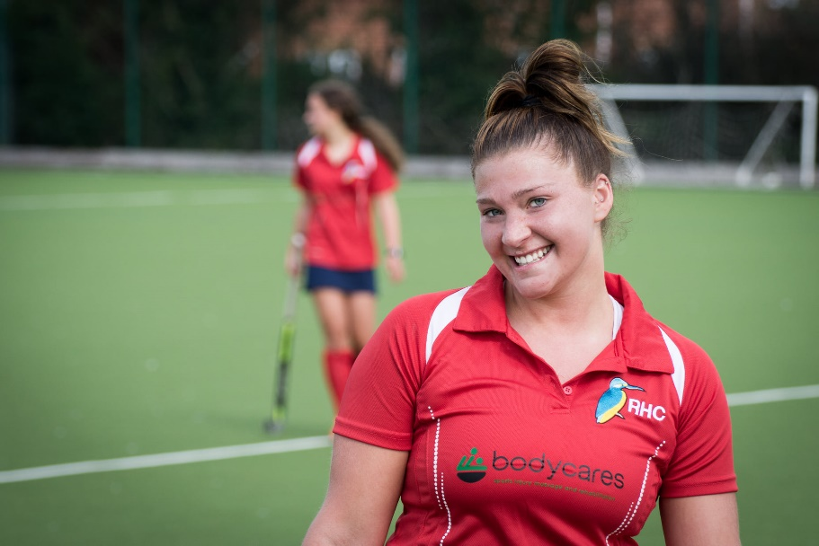

Silver Package (£250)
- 1 year agreement
- 1 single side advertising mesh banner (3m x 1m) on AstroTurf fencing
- 2 membership cards entitling named persons to discounted drinks in the Clubhouse bar
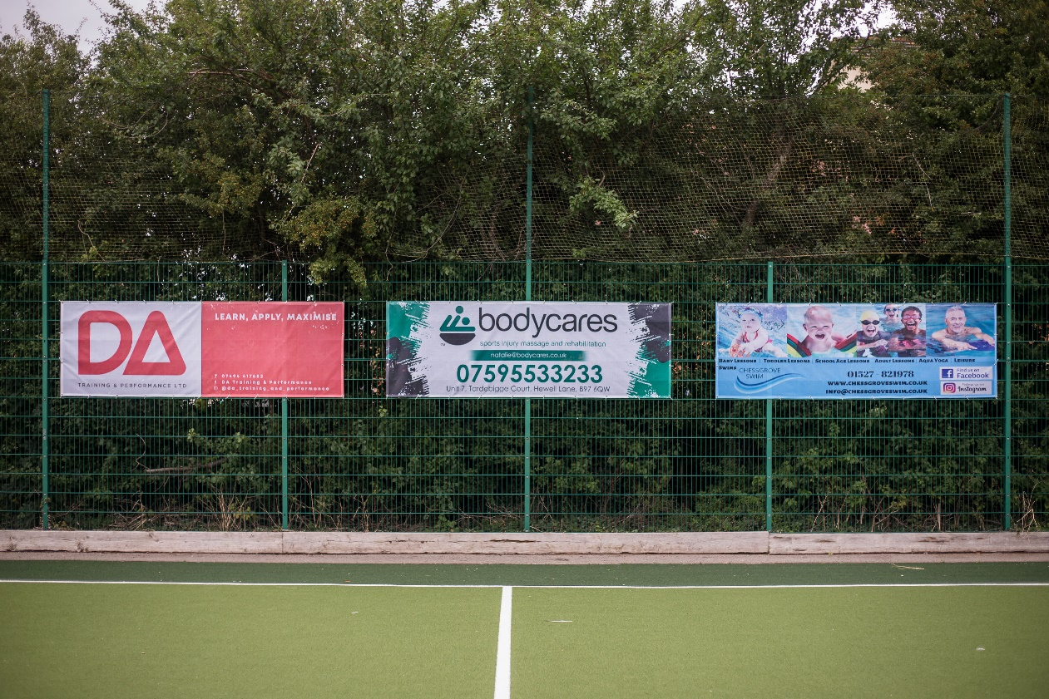
- Presence on the Redditch Hockey Club website with reciprocal links

Coach Sponsorship (£200)
- 1 season agreement
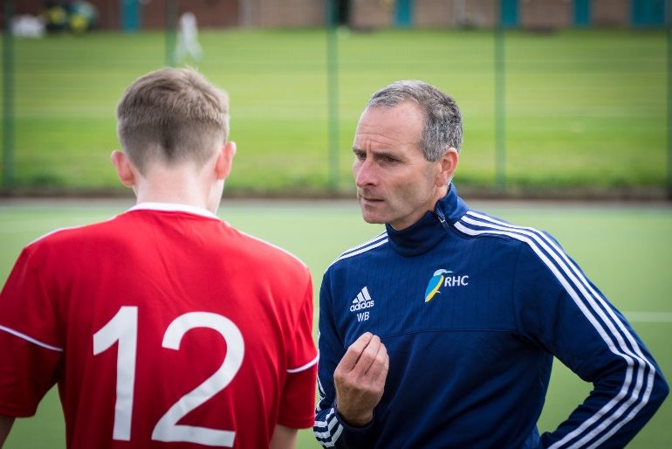
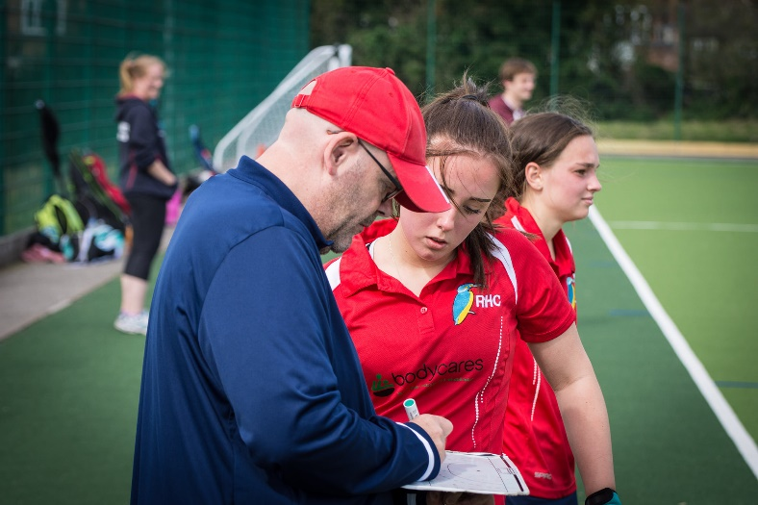
- Company logo on all-weather jacket, worn by coaches at training and on match days

Web Only (£150)
- 1 year agreement
- Presence on the Redditch Hockey Club website
Match Day Sponsorship (£75)
- 1 day agreement, can be agreed in multiples
- Company logo on social media posts detailing match day fixtures, including @tags on Facebook and Instagram
- Company name included in match reports submitted to local newspapers
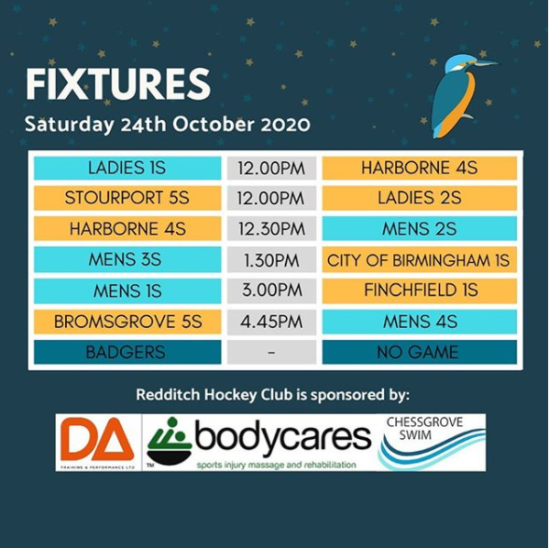

Event Sponsorship (bespoke)
- One off sponsorship of social events e.g. Awards Night, Race Night
- One off sponsorship of organised tournaments
- Sponsorship for events can be monetary or in kind

